**SECONDLIFE**

Submitted in partial fulfillment of the requirements

of the syllabus of

Android Apps Development Lab

in

Information Technology

by

Saarabi Parkar 118A3034

Pavitra Venkatraman 118A3036

Vaishnavi Mantri 118A3025

Under the Guidance of:

Ms. Bushra Shaikh



Department of Information Technology

SIES Graduate School of Technology

2021-22

**CERTIFICATE**

This is to certify that the project entitled **“**SecondLife**”** is a bonafide work of the following students, submitted to the University of Mumbai in partial fulfillment of the requirement of the syllabus of **Android Apps Development Lab** in **Information Technology.**

Saarabi Parkar 118A3034

Pavitra Venkatraman 118A3036

Vaishnavi Mantri 118A3025

Ms. Bushra Shaikh Dr. Lakshmi Sudha Dr. Atul N Kemkar

Internal Guide Head of Department Principal

**PROJECT REPORT APPROVAL**

This project report entitled ***SecondLife*** by following students is approved for the requirement of the syllabus of ***Android Apps Development Lab*** in ***Information Technology.***

Saarabi Parkar 118A3034

Pavitra Venkatraman 118A3036

Vaishnavi Mantri 118A3025

**Name of External Examiner: --------------------------------**

**Signature:--------------------------------**

**Name of Internal Examiner: --------------------------------**

**Signature:--------------------------------**

**Date: 25/10/2021**

**Place: Navi Mumbai**

**DECLARATION**

I declare that this written submission represents my ideas in my own words and where others’ ideas or words have been included, I have adequately cited and referenced the original sources. I also declare that I have adhered to all principles of academic honesty and integrity and have not misrepresented or fabricated or falsified any idea/data/fact/source in my submission. I understand that any violation of the above will be cause for disciplinary action by the Institute and can also evoke penal action from the sources which have thus not been properly cited or from whom proper permission has not been taken when needed.

Saarabi Parkar 118A3034 _____________

Pavitra Venkatraman 118A3036 _____________

Vaishnavi Mantri 118A3025 _____________

Signature

Date: 25/10/2021

**ACKNOWLEDGEMENT**

It gives us immense pleasure to thank Dr. Atul N Kemkar, our Principal for extending his support to carry out and develop the project. We also thank our Head of Department Dr. Lakshmi Sudha for her support in completing the project. We wish to express our deep sense of gratitude and thanks to our Internal Guide, Ms. Bushra Shaikh for her guidance, help and useful suggestions, which helped in completing our project work in time.

We would like to thank the entire faculty of the Information Technology Department for their valuable ideas and timely assistance in this project. Last but not least, we would like to thank our non-teaching staff members of our college for their support, in facilitating timely completion of this project.

**Project Team**

Saarabi Parkar

Pavitra Venkatraman

Vaishnavi Mantri

**ABSTRACT**

Our app is primarily based on the thought of goodwill/charity. If people have extra or used products that they want to rent/giveaway, ranging from something minuscule like books or something major like furniture or electronics, all they have to do is list it out on the app along with the images. The buyer/renter can get in touch with the seller via the app. Further they can collect it based on the pickup location set up.

SecondLife is a mobile application full of different products from people of various walks of life. All these products can be acquired within seconds, without wasting much time on shipping, delivery or other issues. Exchanging and giving away goods and items locally helps hundreds of millions of people to get things that are of so much use to them but might seem unnecessary to others.

**Contents**

|  |  |  |
| --- | --- | --- |
|  |  | **Page No.** |
| **Chapter 1** | **Introduction** | **8** |
| **Chapter 2** | **Survey of Existing Apps** | **9** |
| **Chapter 3** | **Report on Present Investigation** | **10** |
|  | 3.1 Problem Statement | **10** |
|  | 3.2 Source of Problem Statement | **10** |
| **Chapter 4** | **Design and Implementation of Android Apps Components** | **11-17** |
|  | 4.1 Layouts | **11** |
|  | 4.2 Intents | **11** |
|  | 4.3 Activity | **11-12** |
|  | 4.4 Firebase | **13** |
|  | 4.5 Camera | **13-14** |
|  | 4.6 Location API | **14-15** |
|  | 4.7 Generate APK file | **16-17** |
|  |  |  |
|  |  |  |
| **Chapter 5** | **Report on Proposed System and its Implementation** | **18-19** |
|  | 5.1 Flowchart | **18** |
|  | 5.2 Hardware | **19** |
|  | 5.3 |  |
| **Chapter 6** | **Results and Discussions** | 20-23 |
|  | 6.1 Summary of Screenshots with Navigational Flow |  |
| **Chapter 7** | **Conclusions** | **24** |
| **References** |  | **25** |

**Introduction**

On-demand platforms and online trading platforms are services or products that are delivered to you when and where you want them. These platforms have truly changed how the modern-day consumer avails services or buy products.

SecondLife is an extremely useful modern mobile application for retailers and customers. This eCommerce solution makes it possible to buy, lend as well as exchange different goods from different owners in just a few clicks without the necessity to leave one’s home or workplace.

All in all, SecondLife is a mobile application full of different products from people of various walks of life. All these products can be acquired within seconds, without wasting much time on shipping, delivery or other issues. Exchanging and giving away goods and items locally helps hundreds of millions of people to get things that are of so much use to them but might seem unnecessary to others.

**Survey on Existing Apps**

**1.** [**Online Shopping - Buy, sell, and save with eBay**](https://play.google.com/store/apps/details?id=com.ebay.mobile&hl=en)

Founded in 1995 [eBay](https://www.ebay.com/) is one of the largest marketplaces with over 180 million active buyers across 190 markets all over the world. Based on 2.88 million ratings their average rating is 4.37. Online Shopping - Buy, sell, and save with eBay has the current market position #197 by number of ratings.

Features

* **The shopping cart:** The shopping cart makes the buying of multiple items on eBay much easier since you can pay for all of them with a single click-through at the end of the purchase process.
* **Report item:** Use the "Report item" link on the far right of any item listing just above the item number, to report the item directly to eBay for examination, with no further hassle for you.

**2.** [**Wish - Shopping Made Fun**](https://play.google.com/store/apps/details?id=com.contextlogic.wish&hl=en)

[Wish](https://www.wish.com/) is a global e-commerce platform that connects hundreds of millions of merchants and consumers across the world. According to the info on their website, they serve over 70M active users monthly and sell 3 million products daily from 1 million registered merchants. Wish - Shopping Made Fun has the current market position #57 by number of ratings.

Features

* **Dynamic Deals:** Wish is resolutely mobile-first, taking cues from Instagram’s infinite feed and popular gaming apps with elements like a daily “Blitz Buy” wheel users can spin to unlock limited-time deals and pop-ups that promise further unspecified discounts if shoppers add an item to their cart.
* **Communication strategies:** Within 48 hours of signing up for an account, one receives multiple marketing emails pushing one-hour-only discounts, a shop-more-save-more rewards program, $1 watches, and $10 fitness trackers. Wish has replaced loyalty with targeted reengagement.

**Report on Present Investigation**

**3.1) Problem Statement:**

Our app is primarily based on the thought of goodwill/charity. If people have extra or used products that they want to rent/giveaway, ranging from something minuscule like books or something major like furniture or electronics, all they have to do is list it out on the app along with the images. The buyer/renter can get in touch with the seller via the app. Further they can collect it based on the pickup location set up.

**3.2) Source of Problem Statement:**

In highly populated countries like India, food wastage is a disturbing issue. The streets, garbage bins and landfills have ample proof to prove it. The high standard of living has resulted in the wastage of food, clothes, etc. because of quick changes in habits and lifestyle. Instead of wasting these things we can put them in use by donating them to various organizations such as orphanages, old age homes, etc. The product is an internet-based android application that basically aims at charity through donations.

**Design and Implementation of Android Apps Components**

**4.1) Layouts**

A layout defines the structure for a user interface in your app, such as in an [activity](https://developer.android.com/guide/components/activities). All elements in the layout are built using a hierarchy of [View](https://developer.android.com/reference/android/view/View) and [ViewGroup](https://developer.android.com/reference/android/view/ViewGroup) objects.

For our application we used Linear Layout, Frame Layout and Relative Layout for customization of inner components wherever needed.

**4.2) Intents**

An [Intent](https://developer.android.com/reference/android/content/Intent) is a messaging object you can use to request an action from another [app component](https://developer.android.com/guide/components/fundamentals#Components). Although intents facilitate communication between components in several ways

For our application we have used intent to perform an action on the screen. It used to start activity, send a broadcast receiver, start services and send messages between two activities. There are two intents available in android as Implicit Intents and Explicit Intents.

**4.3) Activity**

An activity represents a single screen with a user interface just like windows or frame of Java.Android activity is the subclass of ContextThemeWrapper class. An Android activity is one screen of the Android app's user interface. The Android app starts by showing the main activity, and from there the app may make it possible to open additional activities.

Activity Lifecycle :

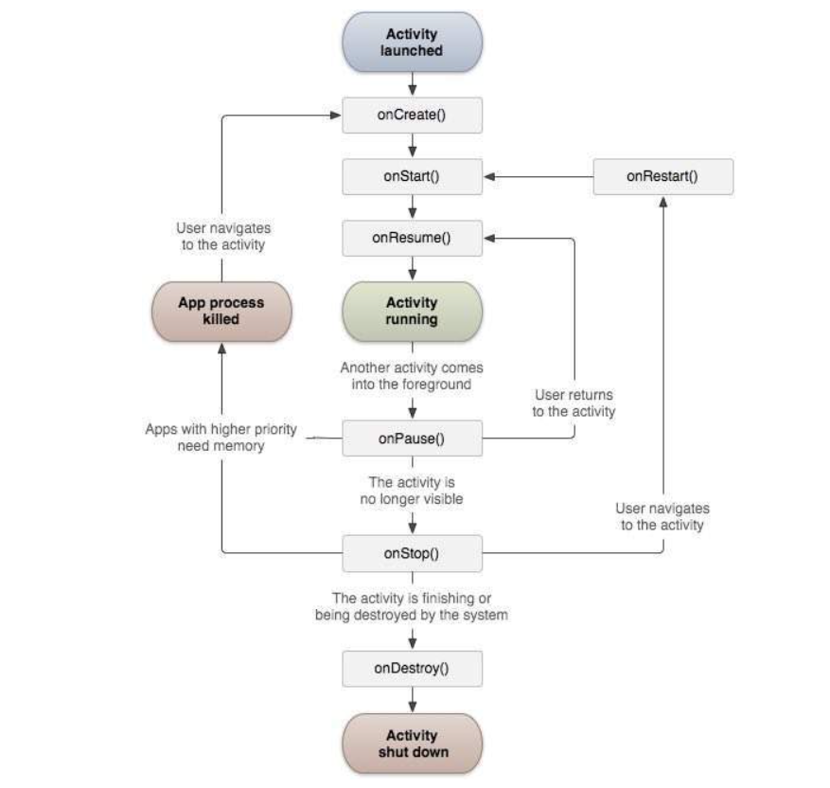

***fig 1***

Activities Screenshot:

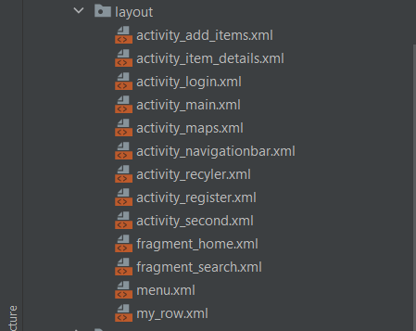

***fig 2: All Activities***

**4.4) Database**

We have used SQLite Database in the Registration and Login module. All the information from the registration page such as Email ID, Password and Contact Number will be stored in the database. The login page checks with the Database, whether the user is already registered or is a new user.

The Add product module makes use of the Firebase Database. Here all the information regarding the product such as Name, description, price, image, location etc are stored. These information are fetched from the database and then displayed in the Listed Items page.

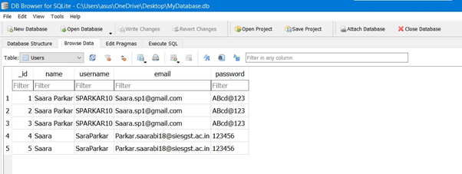

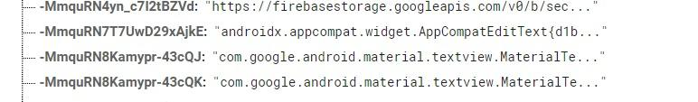

***fig 3: Database***

**4.5) Camera**

In our app the camera feature has been used to upload the pictures of the products to be listed. A user can either take a picture right at that instance or upload an image from his/her gallery. A base catalogue will be made using these images.

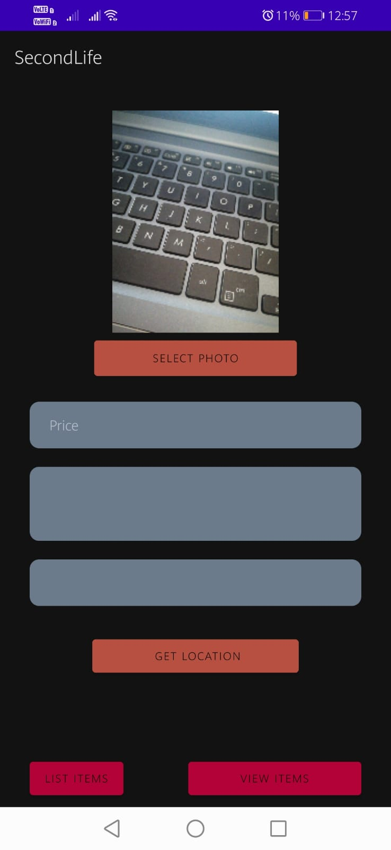 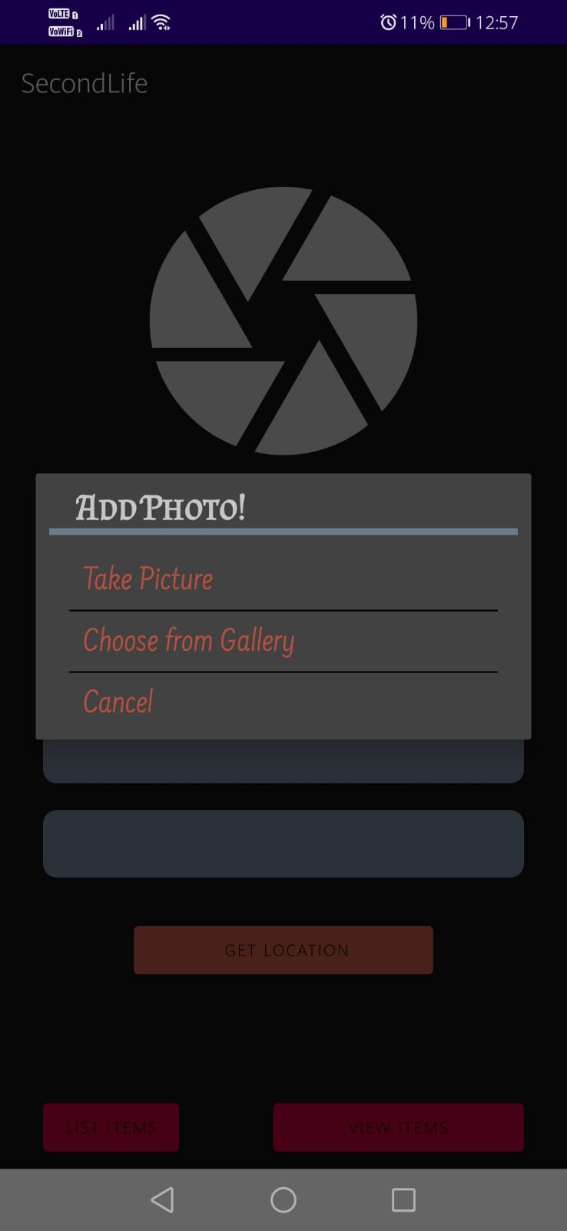

***fig 4: Camera feature fig 5: Dialog box***

**4.6) Location API**

One of the unique features of mobile applications is location awareness. Mobile users take their devices with them everywhere, and adding location awareness to your app offers users a more contextual experience. The location APIs available in Google Play services facilitate adding location awareness to your app with automated location tracking, wrong-side-of-the-street detection, geofencing, and activity recognition.

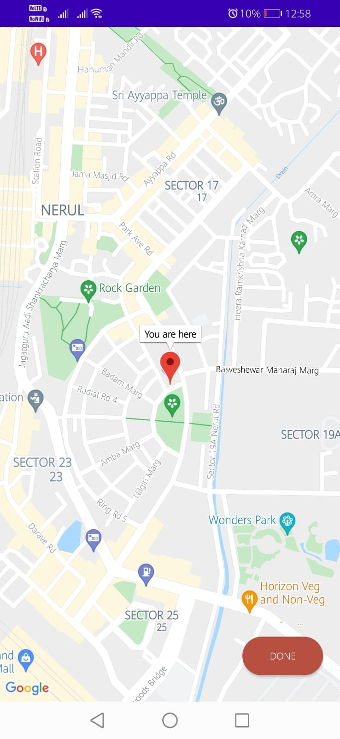 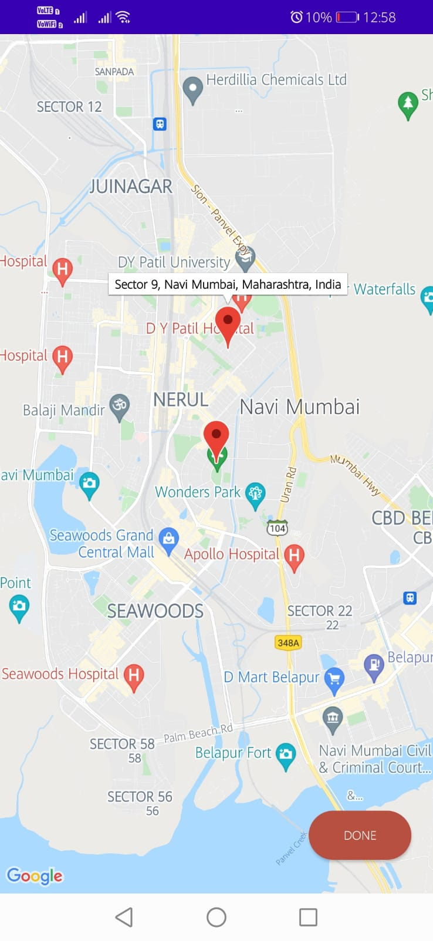

***fig 6: Current Location fig 7: Desired Location***

**47.) Generate APK**

**Step1: Go to Build -> Generate Signed Bundle/APK..**

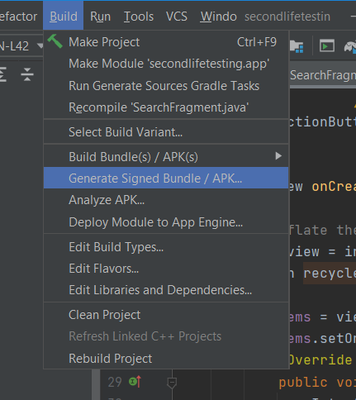

***fig 8***

**Step 2: Select APK and then click on Next**

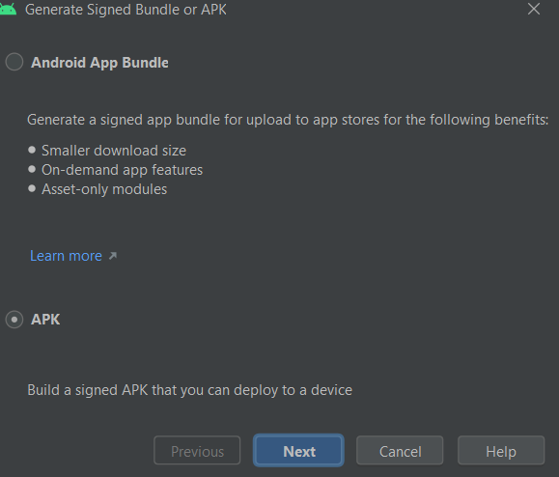

***fig 9***

**Step 3: Choose the directory**

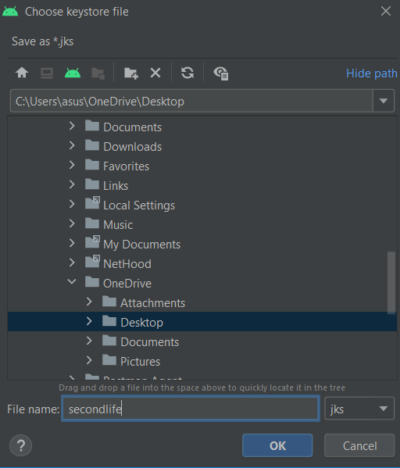

***fig 10***

**Step 4: Enter all the details**

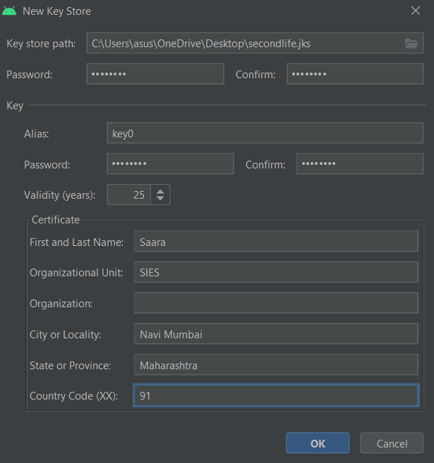

**fig 11**

**Step 5: Select Both the Variants and then click on “Finish”.**

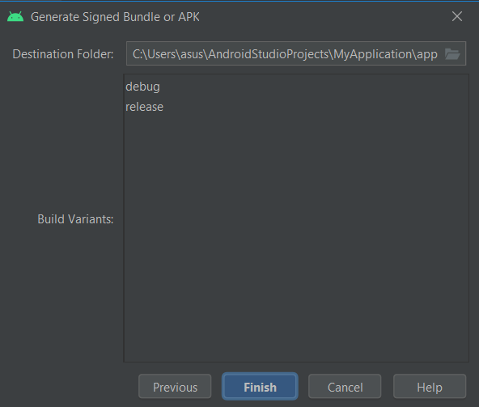

***fig 12***

**Report on Proposed System and its Implementation**

**Flowchart:**

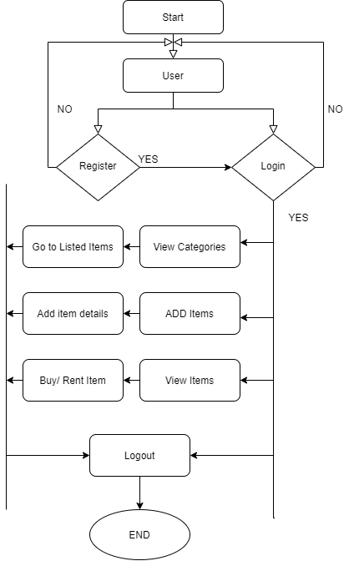

***fig 13: flow chart***

**Hardware –**

* Android Device
* GPS
* Internet
* Camera

**Software / External Libraries used with description –**

* [Firebase](https://firebase.google.com/)
* [FirebaseUI](https://github.com/firebase/FirebaseUI-Android)
* Paypal

**Results and Discussions :**

**Module A:**

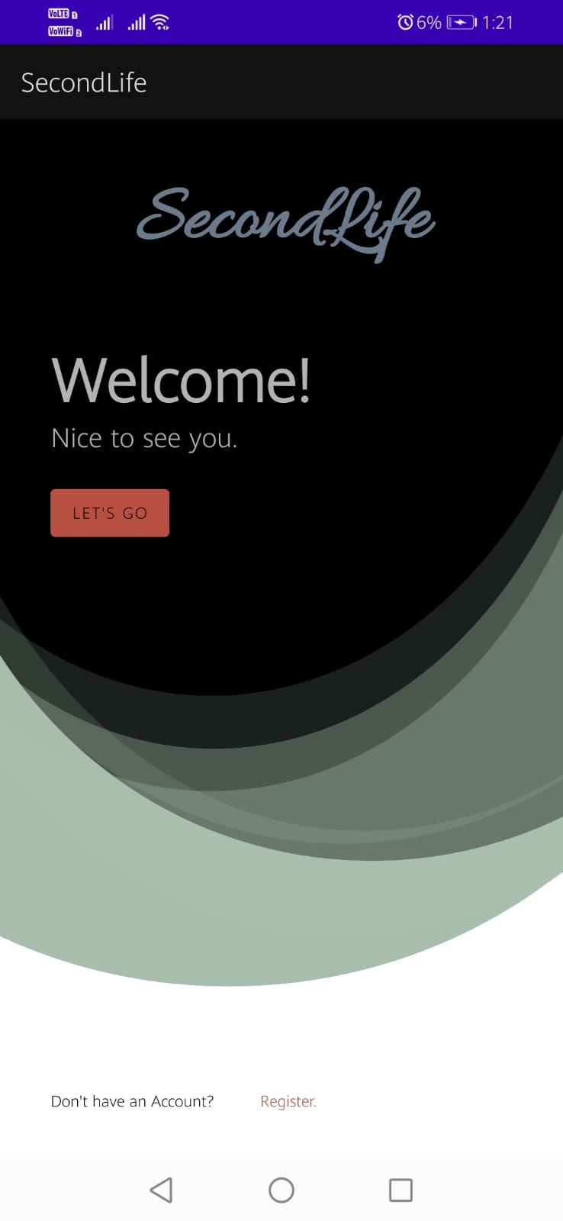 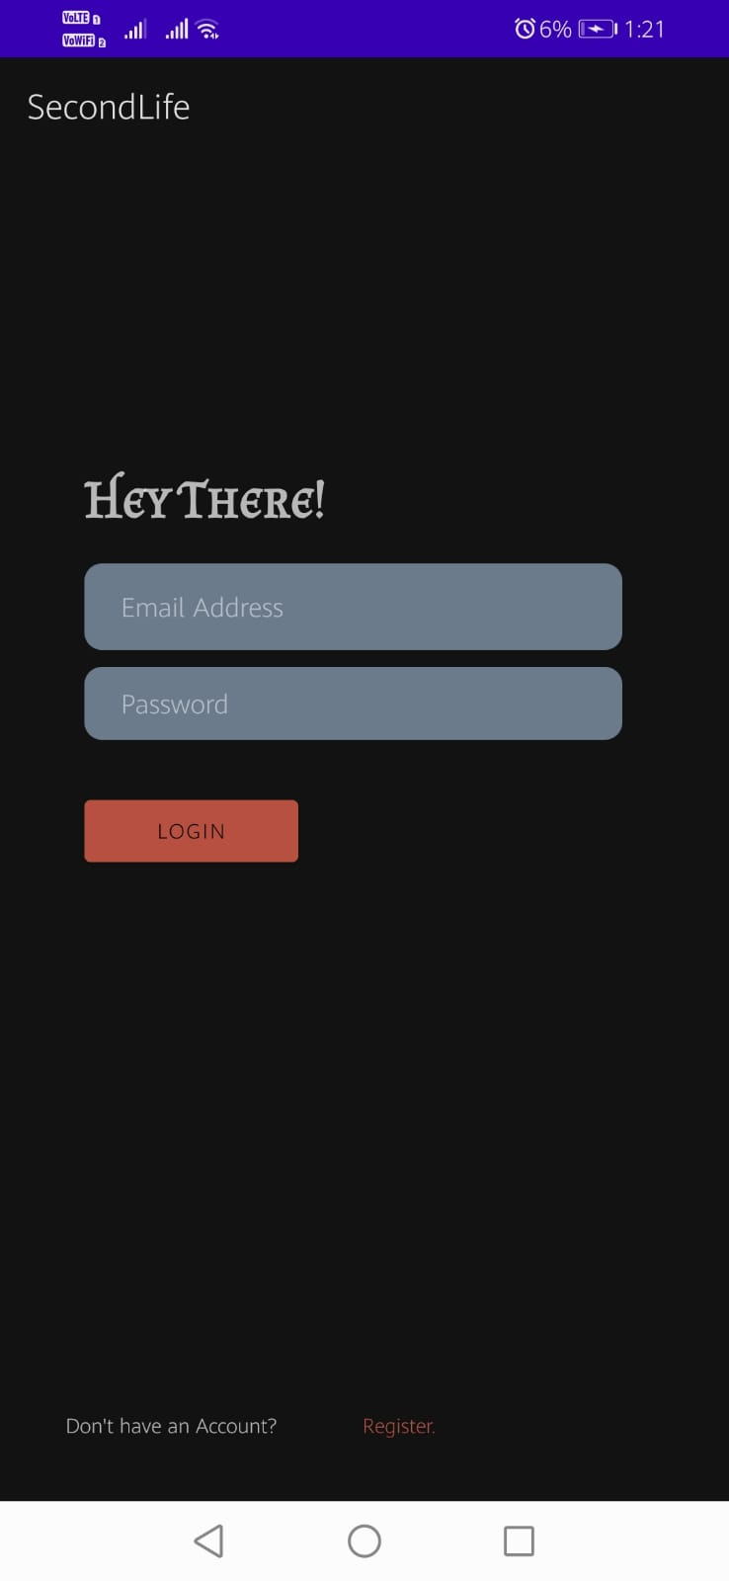 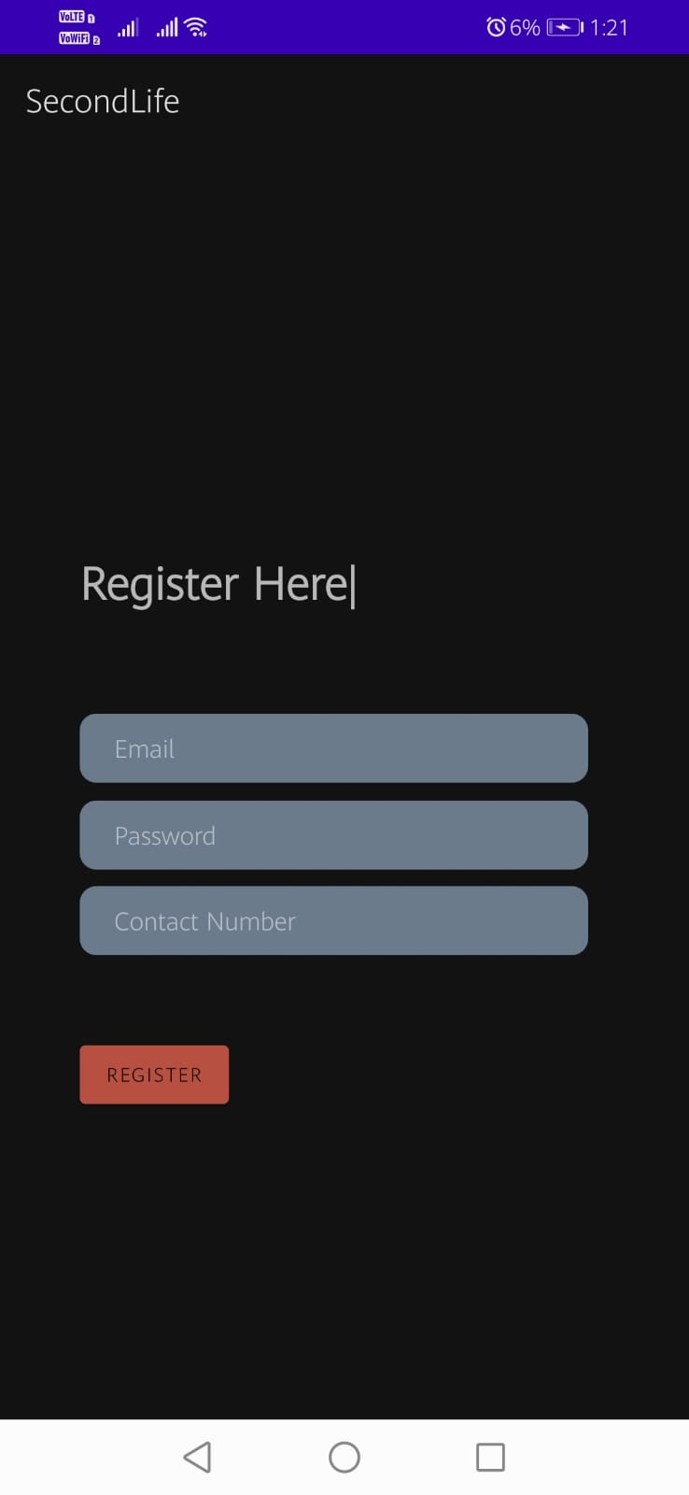

***fig 14: Landing Page fig 15: Login Page fig 16: Registration Page***

This module consists of the Landing page which introduces SecondLife to a user. This will then lead to a Login Page where users have to enter their Email Id and password. If they are a new user, they’ll be redirected to the registration page. Here, the users will register themselves to the app by providing information such as Email Id , Password and Contact number. Once registered, the user can now Login and start using the app.

**Module B:**

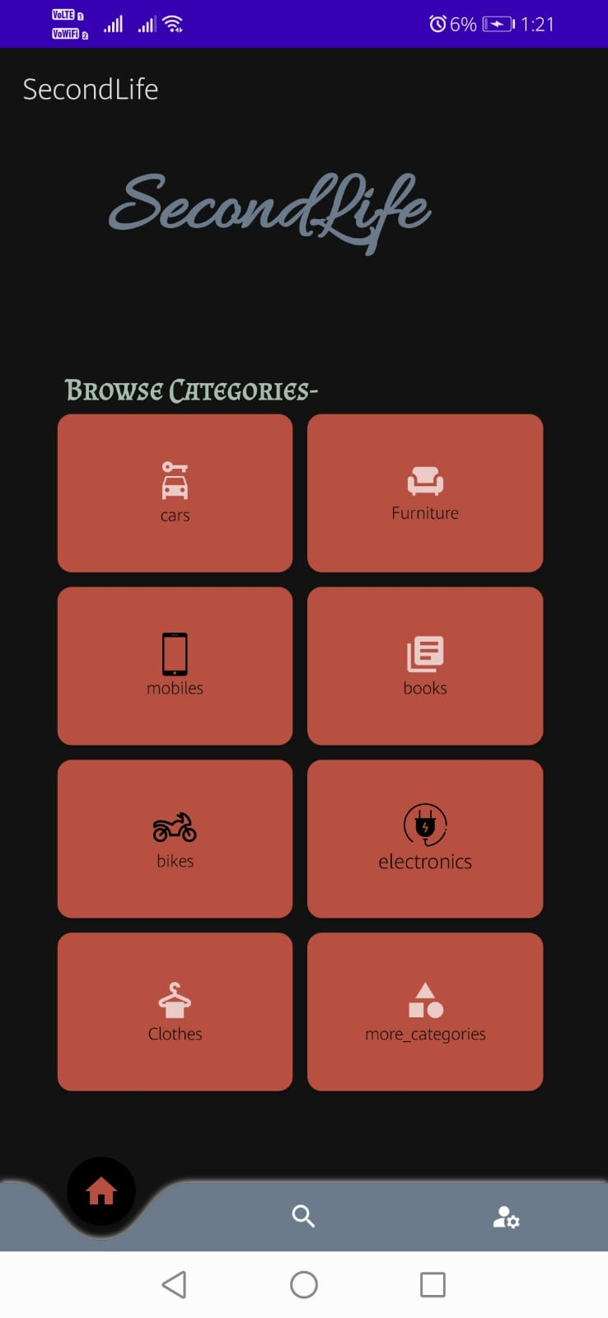 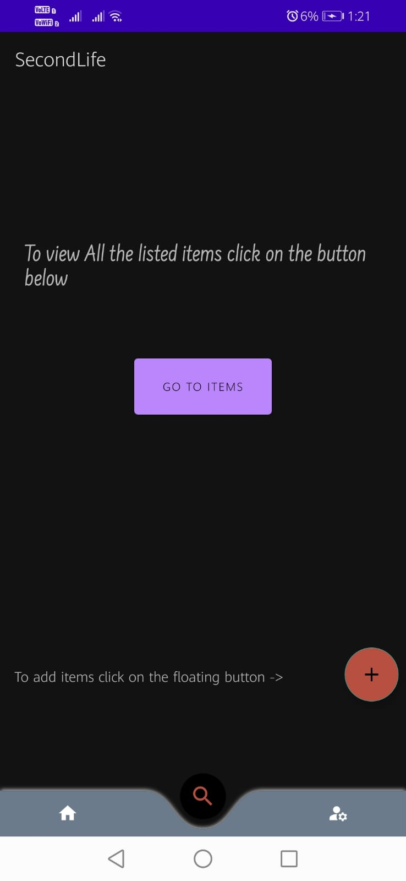 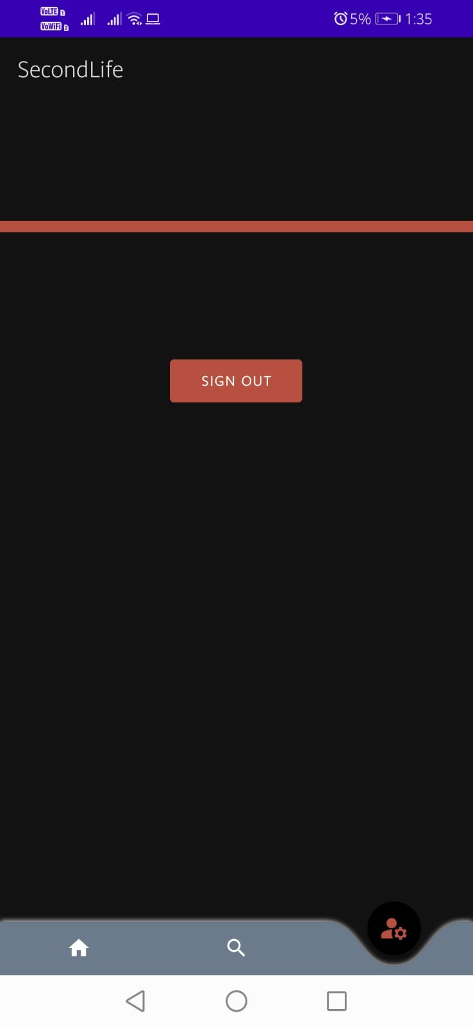

***fig 17: Home Page fig 18: Listing Page fig 19: Sign Out Page***

After Logging In, the user lands on the home page which has the product categories listed. Also using the Navigation Bar, he/she can go back and forth between the home page, listing page and the account page. The Listing page allows users to either browse through all the products that are available or a user can upload a product on the app. The floating button navigates the user to the page where a product can be listed and takes in all the detailed information pertaining to it.

**Module C a]:**

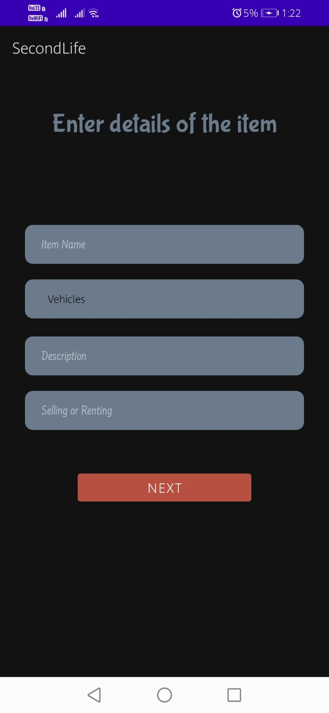 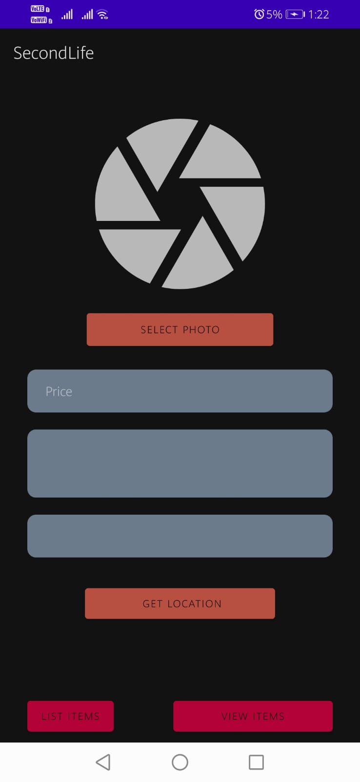

***fig 20: Item Details Page fig 21: Item Details Page***

Users can list out a product by using the floating button in the previous page. One needs to enter all the details associated with the product like Name, Category, Description, Price, Image and also the Location from where they want the buyer to pick up the product. They also have to mention whether the product is for rent or sale.

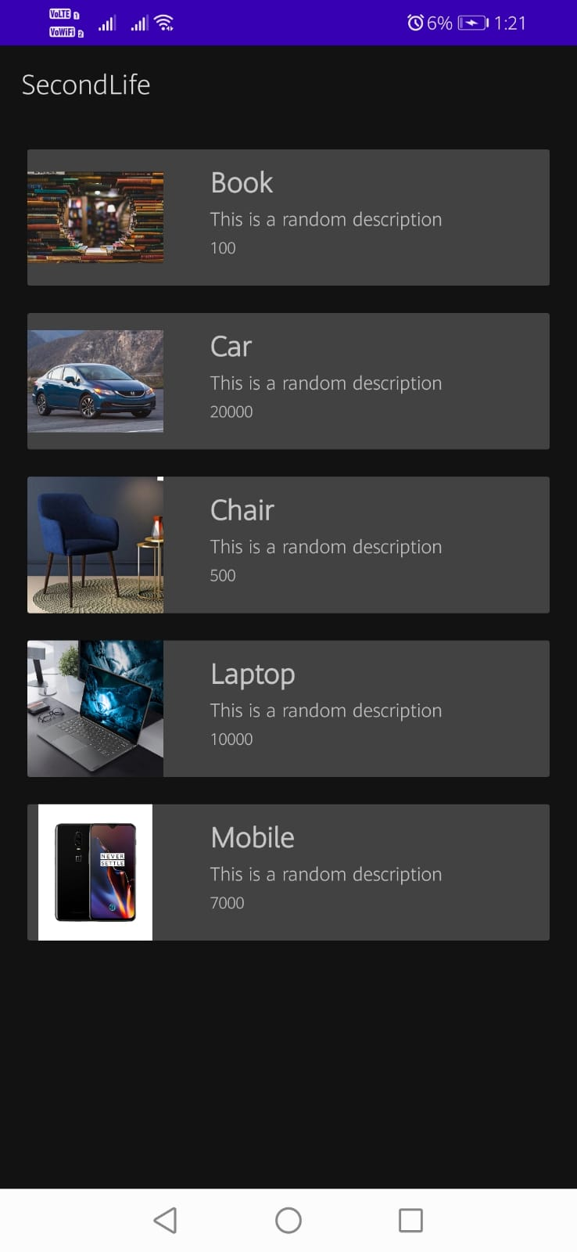 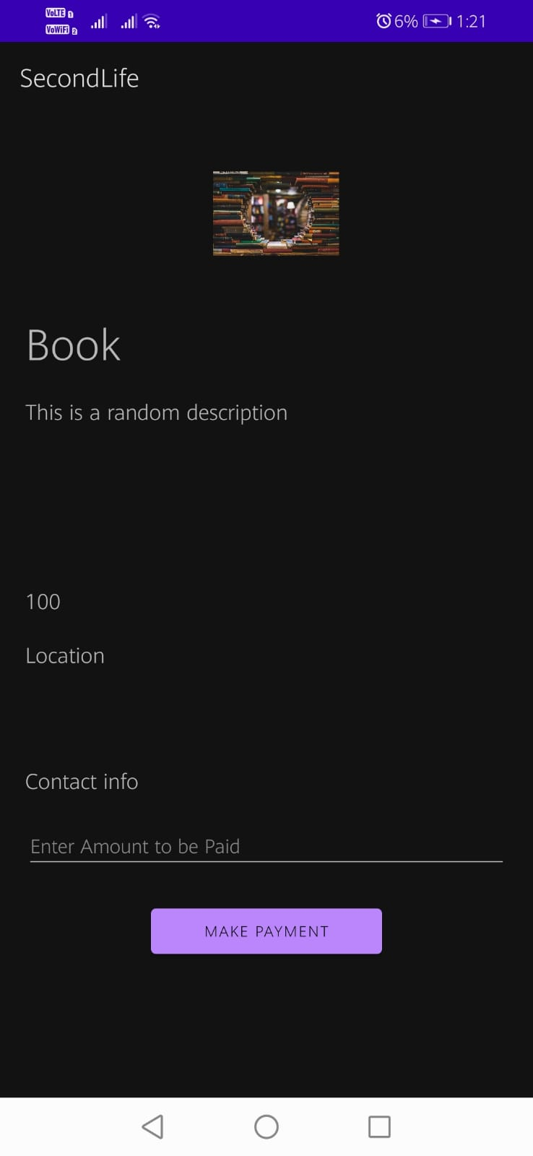 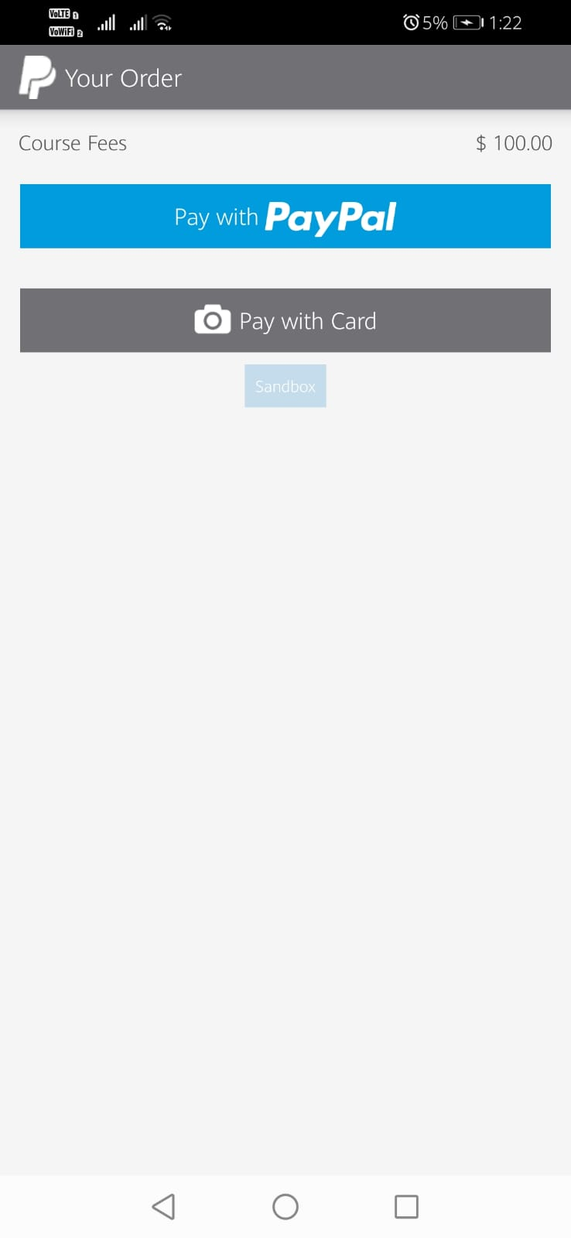

***fig 22: RecyclerView Page fig 23: OnClick Item Page fig 24: Paypal payment Gateway***

In this Module a user can take a look at all the products that are listed. On clicking a product, a detailed overview will be provided about the selected product. The user can then navigate to the make payment button that will redirect them to the Paypal payment gateway. Using this payment gateway, the associated amount can be paid and the user will then come in possession of the product in due time.

**Conclusion**

An app that enables the user to publish Adverts, display them in a RecyclerView. Firstly, the user has to register (if they don't have an account), or login (by using email and password) if they have already registered. Then they are redirected to the Home page, where they can see what categories we offer click on the buttons to view them.

A few Advantages of this application is

1. To aid people who can't afford things.
2. To connect the seller with the people in need.
3. To allow individuals to get what they need with what they already own.
4. As the items are reused, it will decrease the production as the demand is reduced which in turn benefits the environment.
5. To boost Charity Giving.

There is room for improvement. In the future, We want to implement filters in the category listing to improve user experience. We also want to categorise the products based on location so that appropriate products are displayed to appropriate users.

**References**

1. <https://firebase.google.com/docs/android/setup>
2. Firebase authentication, setup, storage, google-signin and notifications documentations.
3. https://www.youtube.com/watch?v=JAEldfC6b-c&list=PLj76U7gxVixSZIec8QSQCxHONZTZbQheG
4. Firebase Cloud Messaging Tutorials to implement the recent changes done in the FCM functions.